

Offside Tag

Referee Assessment – Level 1

Applicants Name Phone

Email Date Venue

**Once rule book is complete, add section and page to answers**

There are two (2) teams of up to fielded players at any given time

1. 6
2. 8
3. 10
4. 12

**Found Under Team Numbers – Page 7**

A maximum of male players can be on the field during a ‘mixed’ game

1. 4
2. 6
3. 7
4. 8

**Found Under Team Numbers – Page 7**

A minimum of players per side is required to play

1. 5
2. 6
3. 7
4. 8

**Found Under Team Numbers – Page 7**

Quick substitutions can occur after (or sooner if replacing an injured player).

1. A down
2. A drop ball
3. Half time
4. Both teams have had one full attacking set each

**Found Under Substitutions – Page 7**

The game will be paused for a noticeably injured player until the

1. Player is rushed from the field
2. Opposition team complains
3. Player is safely removed from the field
4. Siren goes

**Found Under Safety – Page 7**

The winning team from receives an advantage and commences the game with the ball.

1. Heads or Tails
2. Pick a number
3. Guess the hand the whistle is in
4. Tag Off

**Found Under Game Play – Page 8**

The winning team from ‘Tag off’ receives an advantage and commences the game with the ball. The **set commences** with attacker/s on/behind the invisible ‘red line’

1. Throwing the ball above and catching below head height
2. Playing the ball
3. Tapping the ball
4. Kicking the ball

**Found Under Game Play – Page 8**

All **attackers start** behind the behind the red, orange or blue line to commence play with

‘downs’ available.

1. 5
2. 6
3. 7
4. 8

**Found Under Game Play – Page 8**

During play, **attackers can**

1. Be positioned in front or behind the ball
2. Pass in a 360-degree direction
3. Have unlimited passes until ball carrier is tagged
4. All of the above

**Found Under Game Play – Page 8**

**Attackers restart play** once the ball carrier is tagged or loses control of the ball. Play restarts on the

* + Red line - located 27m from the try line if the ball carrier has not been tagged past the orange line
  + Orange line – located 19m away from the try line if the ball carrier has been tagged past the orange line but not past the blue line
  + blue Line – Located 10m away from the try line if the ball carrier has been tagged past the blue line and a try has not been scored

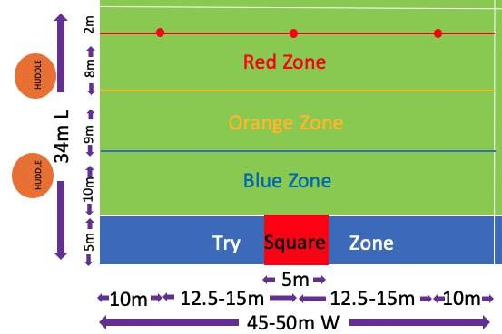

* + 1. True or
    2. False

**Found Under Game Play – Page 8**

**Defenders always start** on the invisible

* + Orange line if attackers start from the red line
  + Blue try line if attackers start from the orange line
  + Try line if attackers start from the blue line

1. True or
2. False

**Found Under Game Play – Page 9**

In a male or female game, how many points does a team receive if they score in the Try Zone ?

Square ?

Red Left/Centre/Right Circle ?

**Found Under Points & Winners – Page 10**

In Under 10’s, attackers starting play on the red line, require both tags to be removed to stop a ball carrier from running with the football

1. True or
2. False

**Found Under Under 10’s Game Variation – Page 10**

**Attackers restart play** once ball carrier is tagged or loses control of the ball. Play restarts on the

1.

2.

3.

**Found Under Attacking Rules – Page 12**

A ‘**changeover’ occurs**

* after 5 downs
* if team scores
* if there is an attacking infringement

1. True or
2. False

**Found Under Attacking Rules – Page 13**

**A down will be called** if a ball carrier

* or ball comes in contact with the during play
* has their out and a defender is in tagging distance
* fends, bumps or shields tags with a body part or
* steps outside the field of play (including invisible field boundary lines)
* falls on the ground or the ball is dropped by either team
* throws the ball to themselves to avoid being tagged
* is purposely ‘shielded’ by a team player
* removes their own tag
* purposely delays or ‘baulks’ a set start
* receiver collides with a defender
* a ball

**Found Under Attacking Rules – Page 13**

**Defenders start** their defensive set on the invisible

* orange line – located 19m away from the try line if the ball carrier has not been tagged past the line and a try has not been scored
* blue Line – Located 10m away from the try line if the ball carrier has not been tagged past the line and a try has not been scored
* try Line – if the ball carrier has been tagged past the line and a try has not been scored

**Found Under Defending Rules – Page 14**

Name 3 ways a defender can/will be penalised

1.

2.

3.

**Found Under Defending Rules – Page 15**

Name 3 reasons a **referee can rule an infringement**

1.

2.

3.

**Found Under Penalties & Infringements – Page 15**

**Referees are equipped with** a

1. W
2. P
3. P

**Found Under Penalties & Infringements – Page 16**

Referee etiquette includes

1.

2.

3.

**Found Under Referee Etiquette – Page 18**

Provide the Offside Tag YouTube channel link and name write the date of a referring tutorial/video

1. Link

**Hint: Google Offside Tag Youtube????????????**

Score / 23 Is the prospective referee competent Y / N Assessor Comments

Name Signature